Experiment No. 2

Title: Google analytics set up for website.

Batch: B–1 Roll No.: 16010422234 Experiment No.: 2

Aim: Setting up Google Analytics for Website

Resources needed: Internet and MS-office

Theory:

GOOGLE ANALYTICS
Knowing your audience and what they want is an important success factor for any website. The best way to know your audience is through your traffic stats and this is exactly what Google Analytics does. Google Analytics is one of the top, most powerful tools out there for monitoring and analysing traffic on your website. For using analytics one should create the account and then need to copy the tracking code. Once you add the tracking code to your webpages, Google analytics will track the various activities on the website and will generate the reports for it.

Learning Extension Resources:
https://www.youtube.com/watch?v=ZXSI5R7GeVA (Timestamp 0-2.58)

Procedure:
1. Create an account for Google Analytics.
2. Add basic page tracking to the website by copying the code snippet.

Results: (Stepwise procedure (with snapshots) for above question)
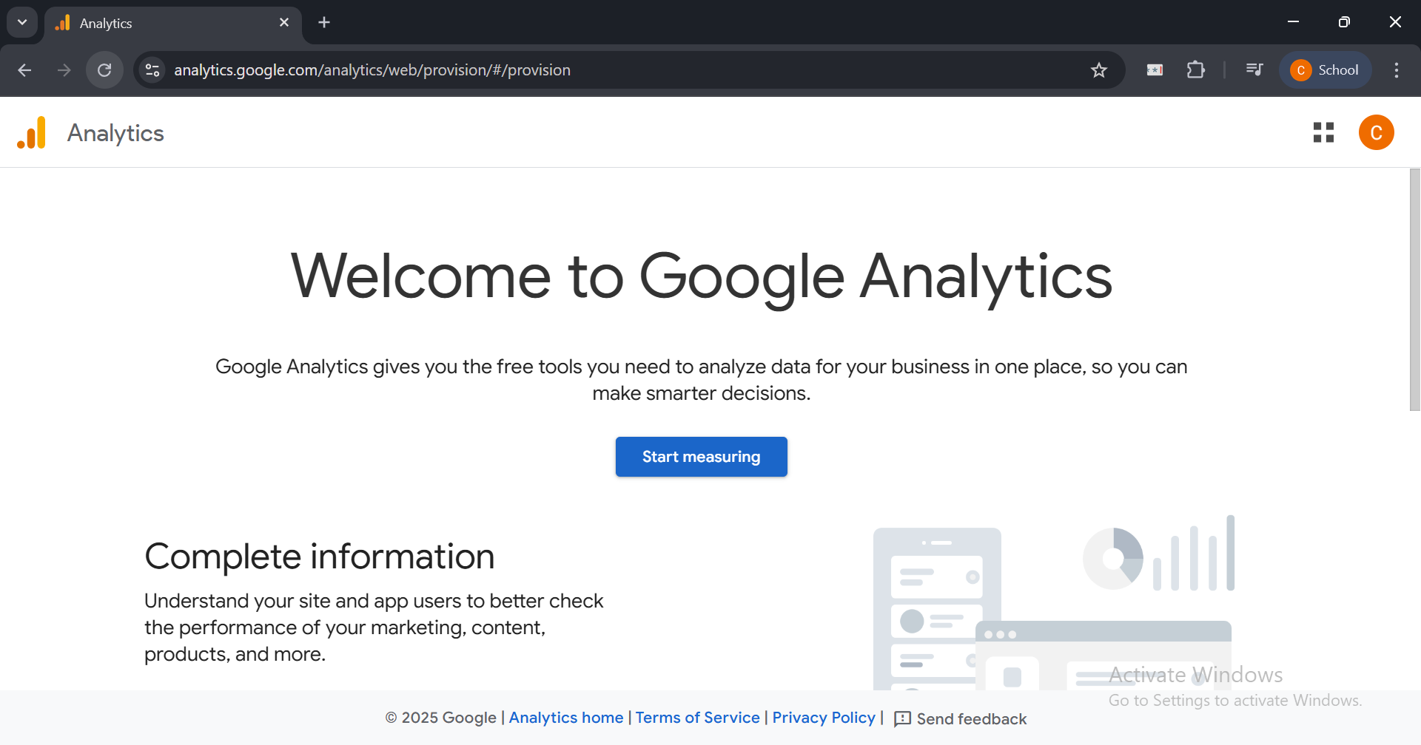

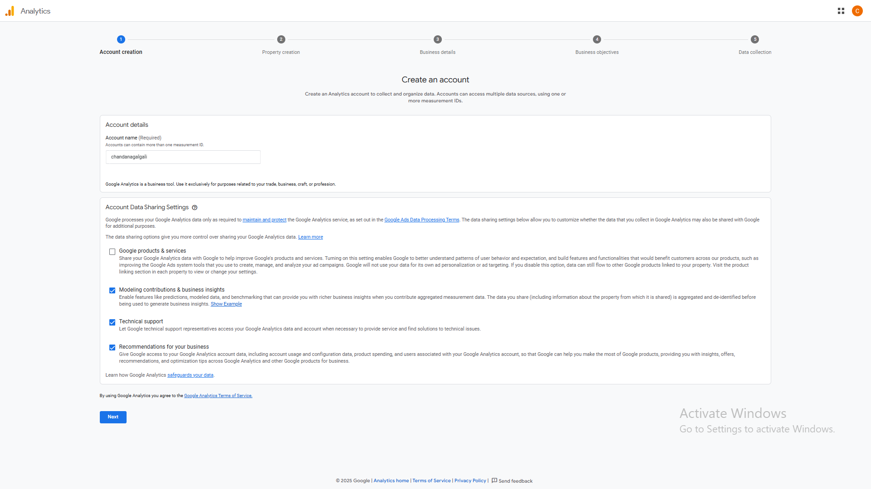
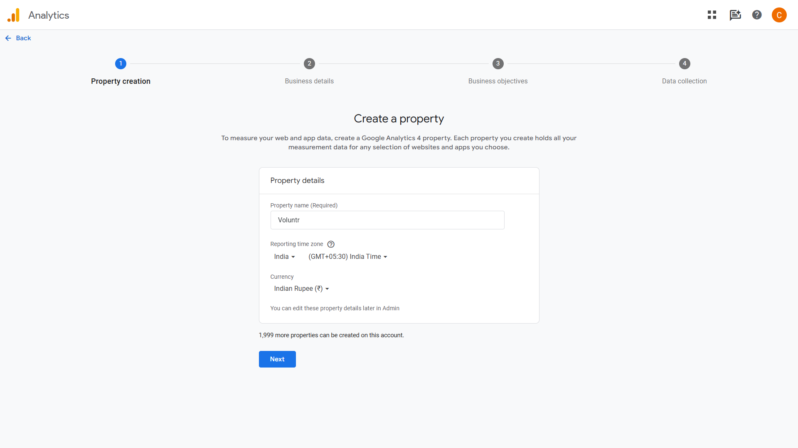

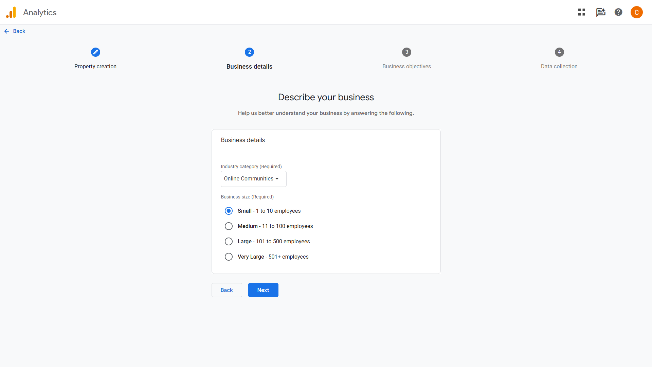
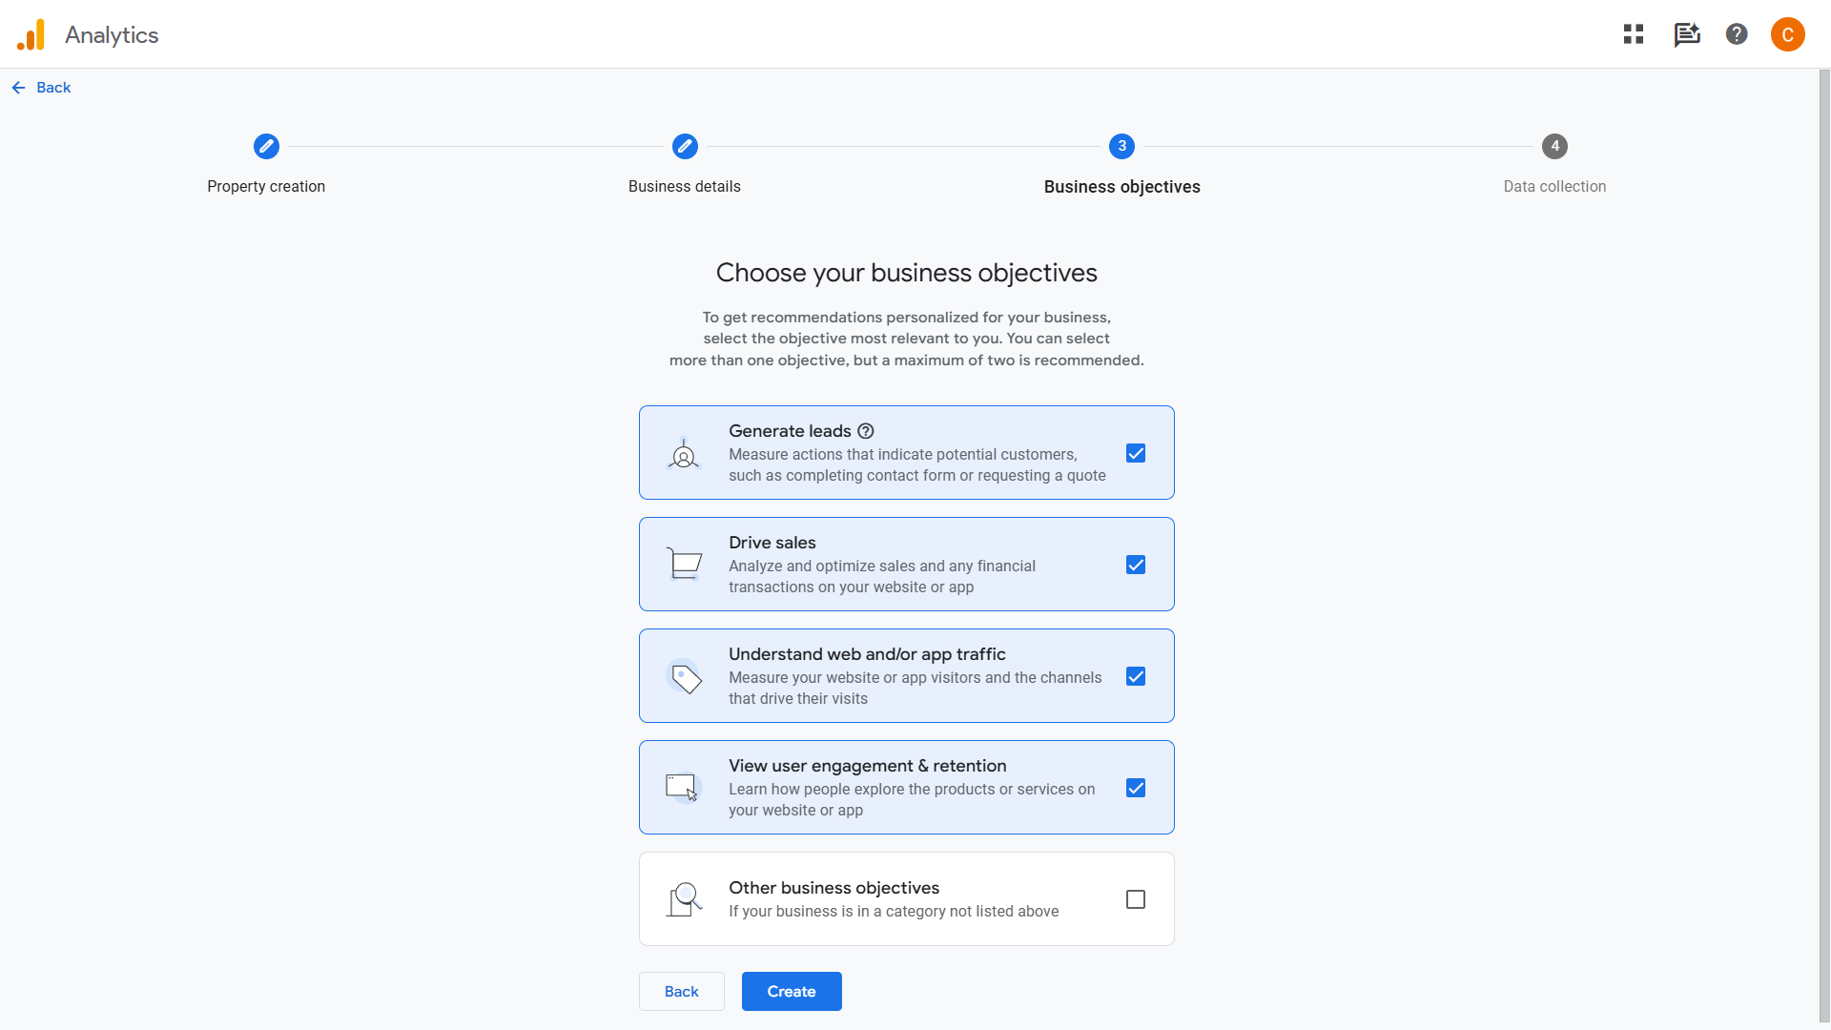

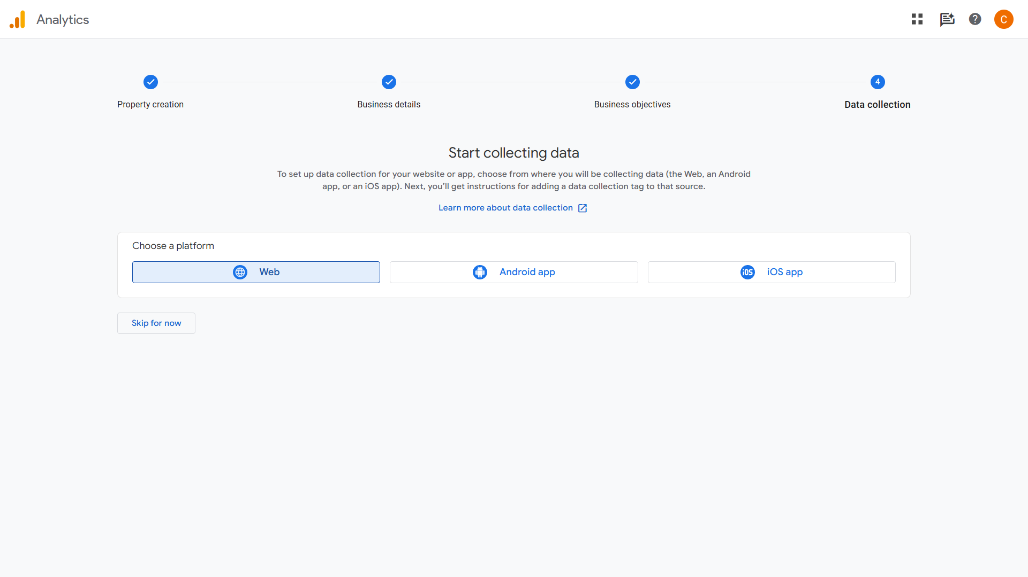
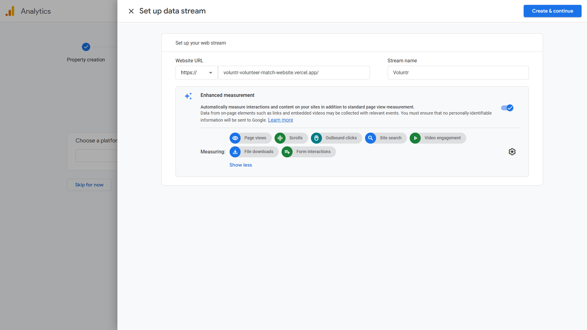

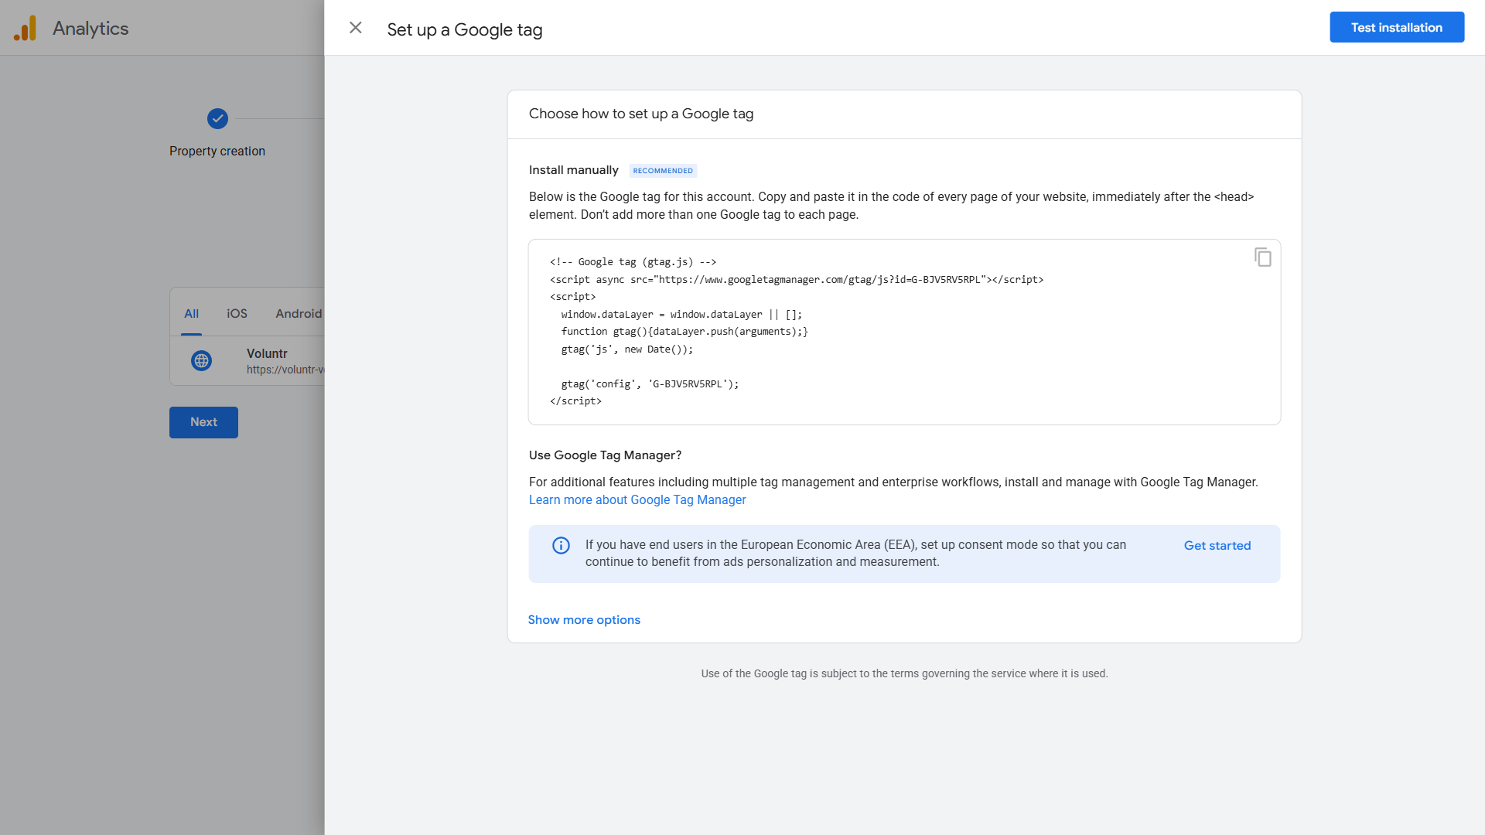
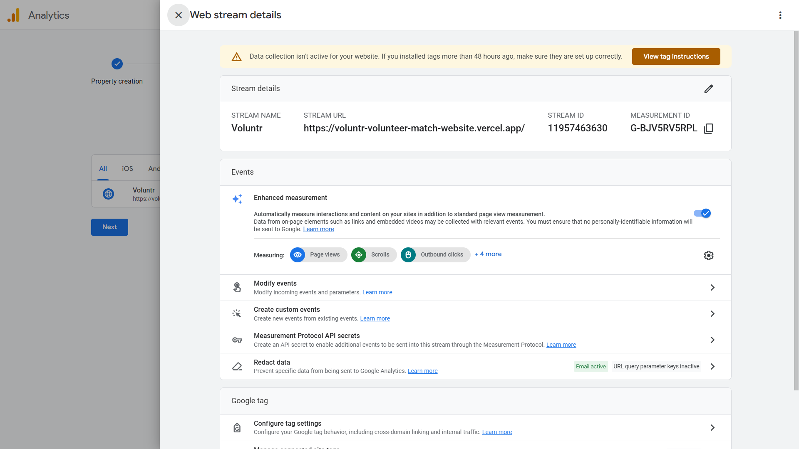

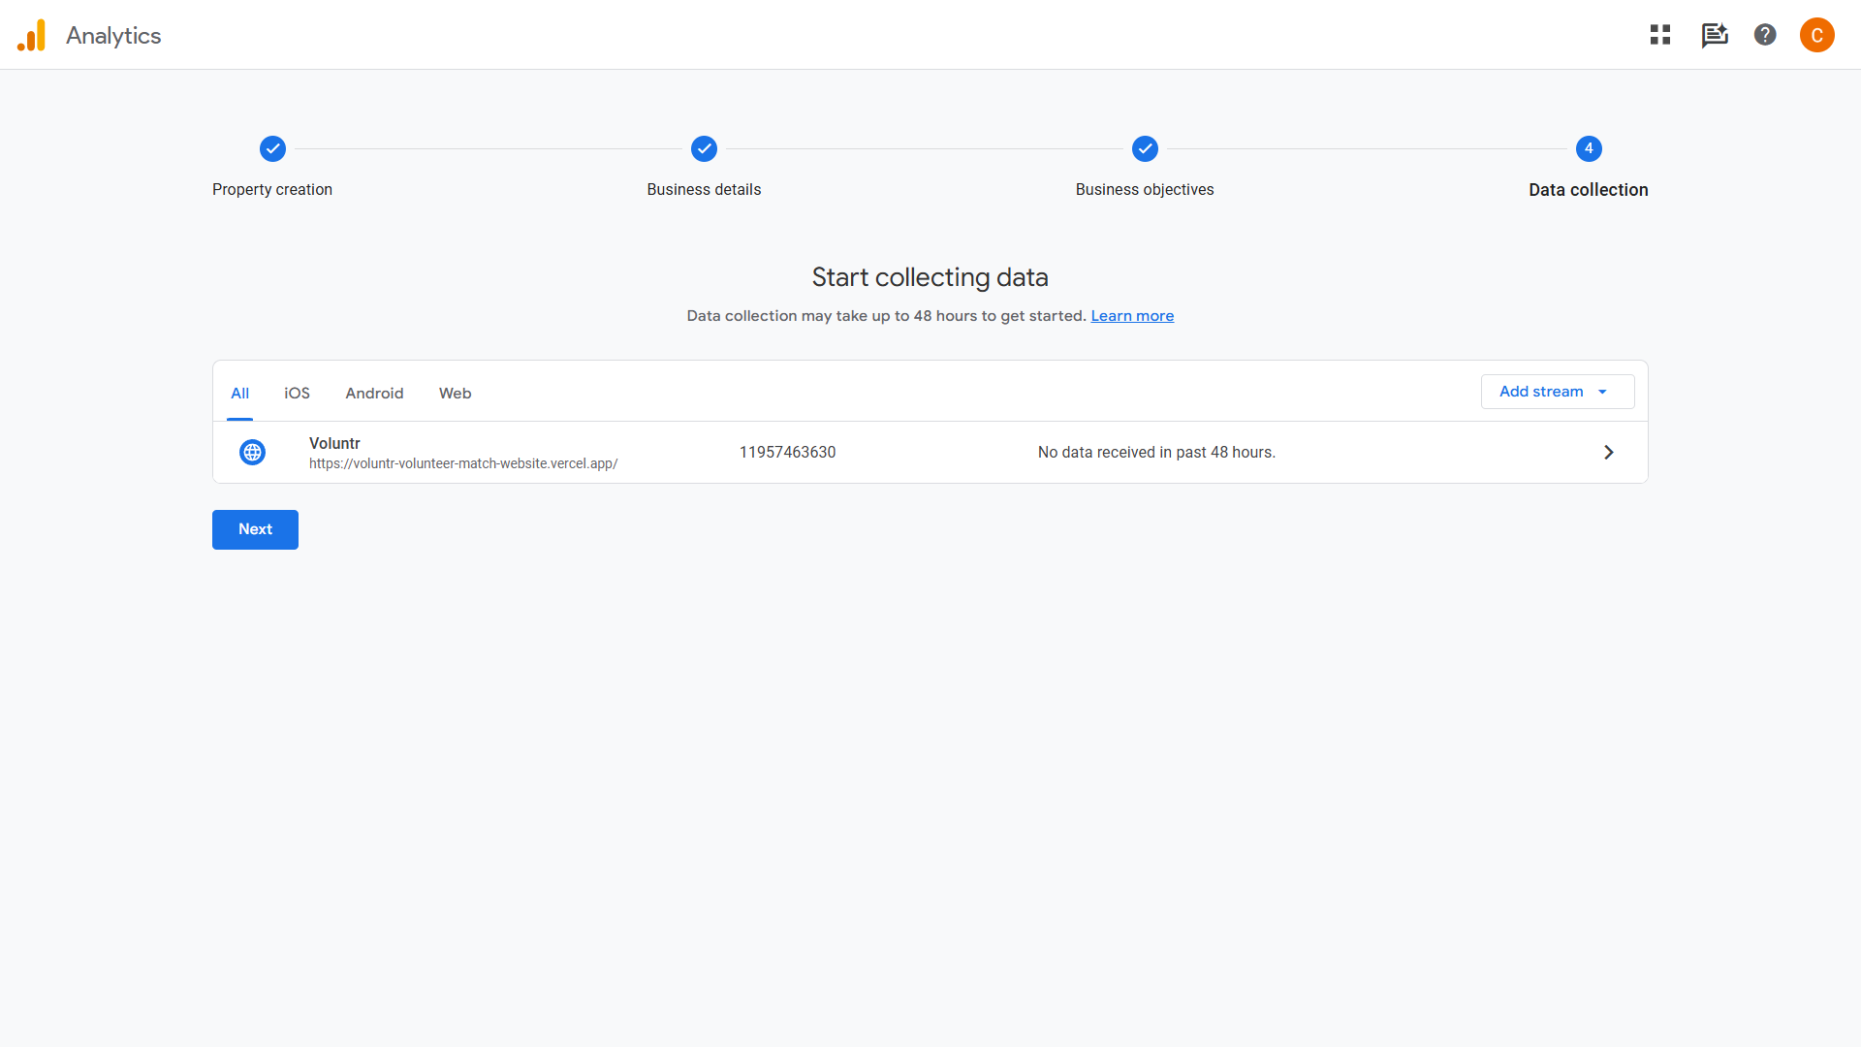
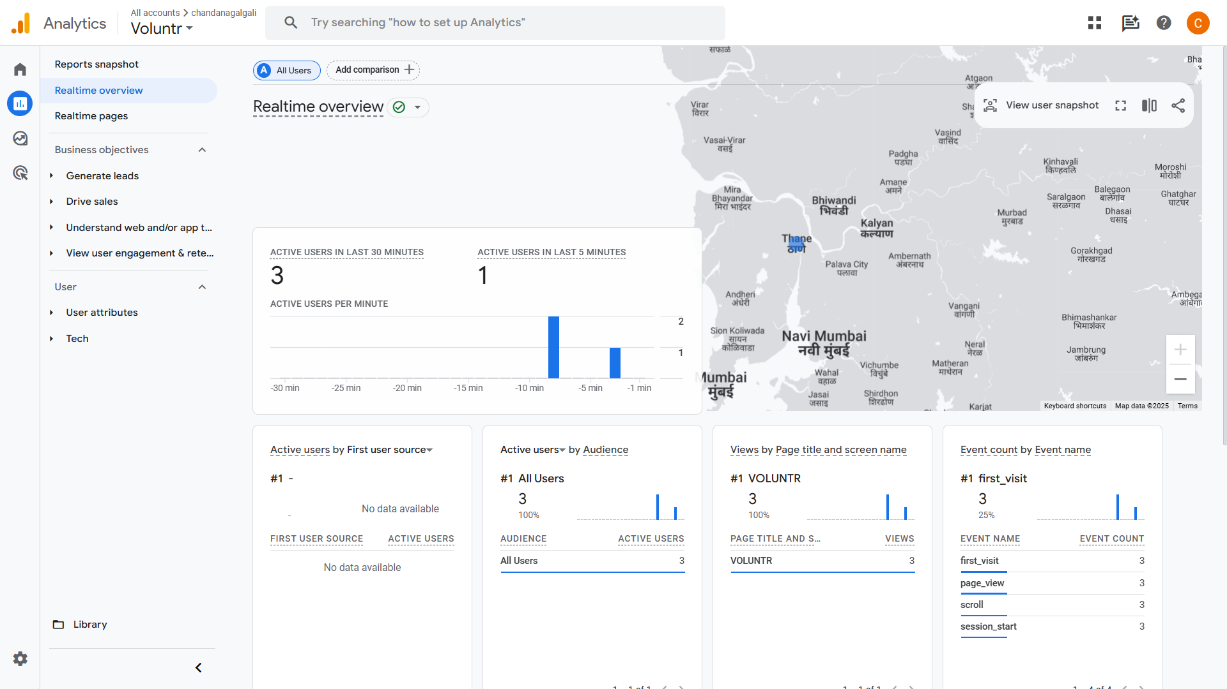

Outcomes: CO2 – Understanding search engine optimization essentials

Conclusion: (Conclusion to be based on the objectives and outcomes achieved)
The integration of Google Analytics into a website is a crucial step in understanding user behavior and improving the digital marketing strategy. By setting up Google Analytics and adding the tracking code, we gain valuable insights into user engagement, traffic sources, and conversion metrics. These insights allow businesses and website owners to make data-driven decisions that optimize content, user experience, and overall marketing efforts. In essence, Google Analytics empowers businesses to enhance their online presence by providing a clear picture of audience activity and website performance. Through this experiment, we comprehended the shift in marketing strategies towards a more data-driven and analytical approach, highlighting the significance of tools like Google Analytics in modern digital marketing.

Grade: AA / AB / BB / BC / CC / CD / DD

Signature of faculty in-charge with date

References:
1. Eric Enge, Stephan Spencer, Jessie Stricchiola, Rand Fishkin, “The Art of SEO, Mastering Search Engine Optimization”, O'Reilly Media; 2nd edition, 2012
2. John I Jerkovic, “SEO Warriors”, O'Reilly Media; 1st edition, 2009
3. RafiqElmansy, “Teach Yourself VISUALLY Search Engine Optimization (SEO)” John Wiley & Sons, 2013

